VR Reflection Report
Breakdown of the project:
My Virtual Reality application was a zombie shooter style of game following the scary/Halloween theme of the project given to us. The player spawns in a graveyard where zombies were meant to come towards the player. Guns were used to kill the zombies as the player must fight off the zombies until they are either all dead or the player is killed.

Development of the project:
I used resources that we were given in our class as part of tutorials on learning how to set up a virtual reality scene within unity. I implemented an XR rig within the scene from the tutorials.
I then added a terrain into the project and used many brush styles to give height and variation to the scene. Hills were used to stop the player from being able to view the edge of the terrain to give a more immersive experience. Trees, gravestones, and buildings were added to create a spooky graveyard feel. All my assets came from Kenny.nl.
Adding fog and a sky box to the scene to reduce the players view and give a darker hue to the environment were added with ease. Next was lighting that needed to be added to the light post objects. The light post objects used a point light to disperse small amounts of light around the scene to keep the scary/horror feel of the game.
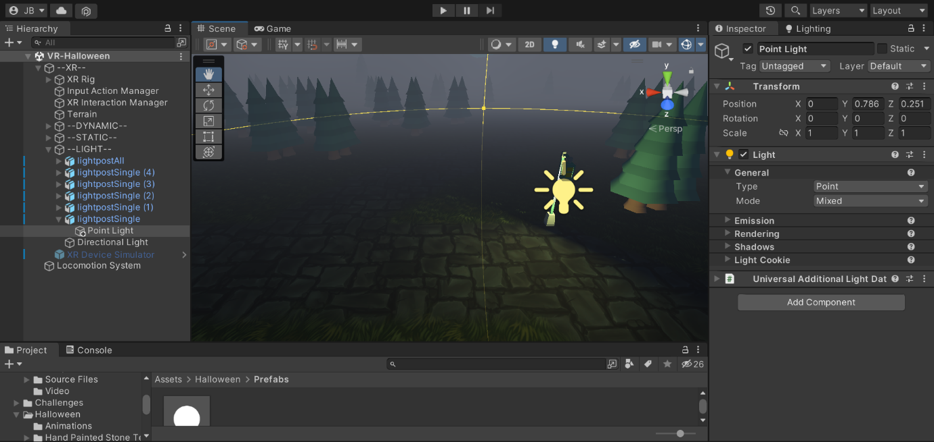

After I had my terrain and surrounding objects added to the scene I began on creating my weapons. I used a simple pistol asset and added a object to the tip of the gun where my bullets would spawn from when it is called to shoot.
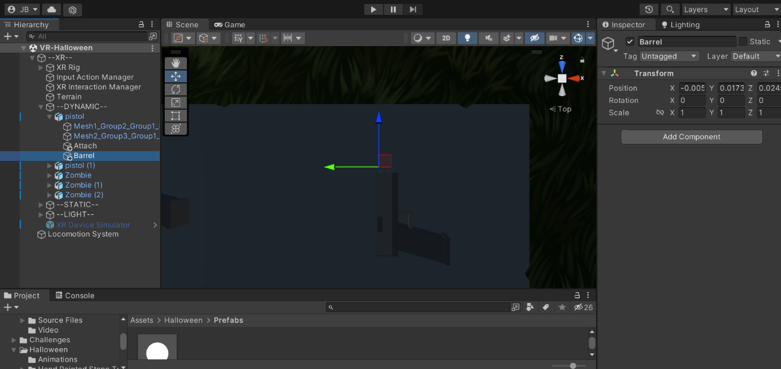
The bullet would spawn from the barrel object once the shoot function is called in a script attached to the gun. The bullet was just a simple prefab of a sphere object which can be seen at the bottom of the image above. Grabbable objects were also implemented at this point to allow the player to pickup the gun using an attach object on the gun.
The next step in creating the project was to implement the zombies. I used a ragdoll for the zombie object as I wanted the zombie to fall to the ground after the bullet collided with it. I encountered problems from this point as my project had an error and I could not deactivate the ragdoll when the game started. I tried to fix this for a greater portion of the remaining time we had on the project but could not find a fix.
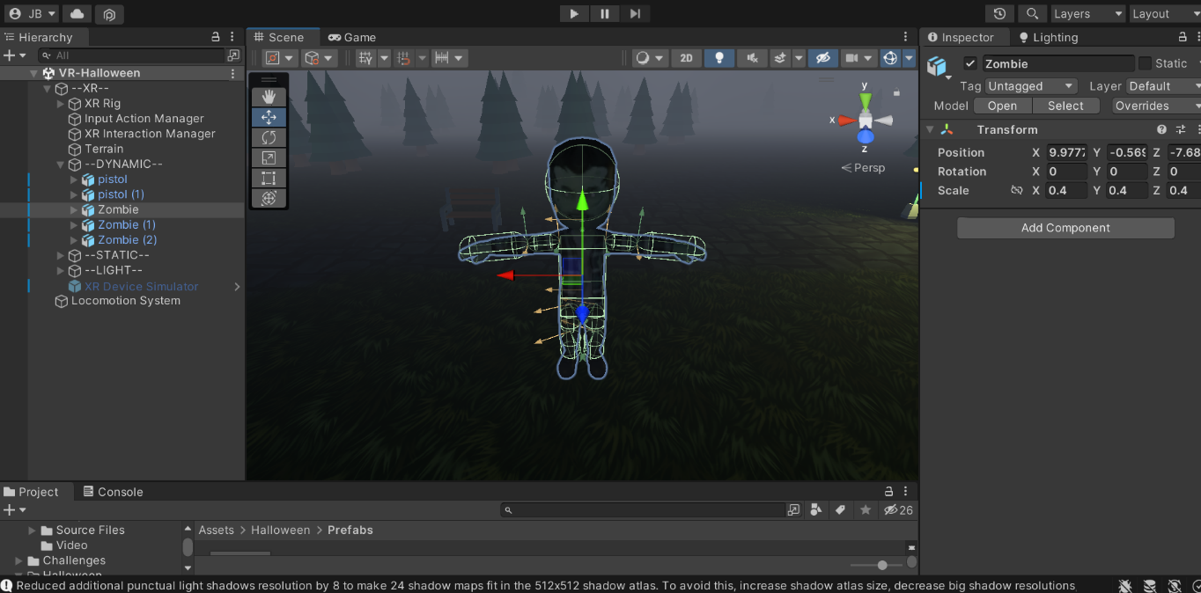

Continuing with the project after I could not find a fix for the ragdoll issue I implemented sockets which were used to add hats and pumpkins to the zombies head. The locomotion system I added used a continuous system so the player could freely walk around the scene using the sticks on the VR controllers. Images are below.
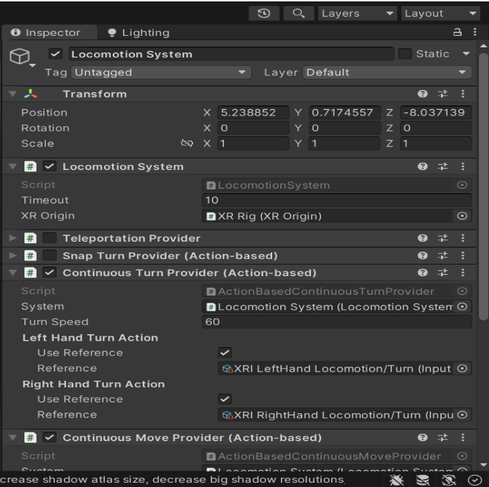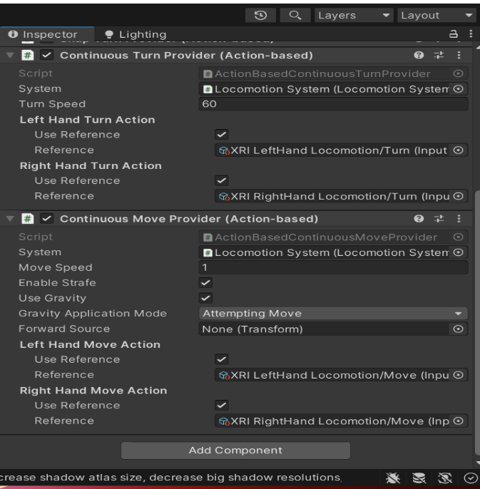

What I have learned and plan to improve on:
In the development of this project, I learned how to create ragdolls, build an immersive terrain for the player, and how to set up virtual reality application more efficiently as I have had more experience with the topics covered in our lectures. I plan to improve on my ability to better manage my time within a project and focus more on critical or essential items to be added first. I will also continue on trying to improve my ability on creating enemies with ragdolls.

